Grade 5 Mentor Texts:
Interpretation Text Sets

In order to teach students how to think about how books are connected by ideas (themes), we need to have both new and familiar texts available for teaching:

- During the Read Aloud, select a new novel to read such as:
- Pictures of Hollis Woods, Patricia Reilly Giff
- The Great Gilly Hopkins, Katherine Patterson
- Music of the Dolphins, Karen Hesse
- Esperanza Rising, Pam Munoz Ryan
- Number the Stars, Lois Lowry

- Choose a few picture books that could also be interspersed periodically during the Read Aloud time. Your choice of picture books would influence the theme(s) that could emerge across texts. It is suggested in the unit that you also select short nonfiction pieces and poems that also relate to these themes. The following picture books address themes related to growing up, fitting in, diversity, courage, and honor:
- Pink and Say, Patricia Polacco
- Gleam and Glow, Eve Bunting
- The Giving Tree, Shel Silverstein
- The Granddaughter’s Necklace, Sharon Dennis Wyeth
- Wings, Christopher Myers
- Harmonica, Tony Johnston
- Faithful Elephants, Yukio Tsuchiya
- Selections from Baseball in April and Other Stories, Gary Soto

- Make connections back to mentor texts used during previous Reading and Writing Units (i.e. from earlier in the year and previous years):
- Tiger Rising, Kate DiCamillo
- Edward’s Eyes, Patricia MacLachlan
- Because of Winn-Dixie (Grade 4), Kate DiCamillo
- Short texts such as Charles, Shells, Eleven, My Name in Gold

Interpretation Text Sets - Grade 5

MENTOR TEXTS

Read Aloud Suggestions
GR  LEVEL | LEXILE | TITLE | AUTHOR | BOOK TYPE | PHOTO
V | 650 | Pictures of Hollis Woods  Hollis Woods has been in so many foster homes she can hardly remember them all. She even runs away from the Regans, the one family who offers her a home.  When Hollis is sent to Josie, an elderly artist who is quirky and affectionate, she wants to stay. But Josie is growing more forgetful every day. If Social Services finds out, they’ll take Hollis away and move Josie into a home. Well, Hollis Woods won’t let anyone separate them. She’s escaped the system before; this time, she plans to take Josie with her.  Yet behind all her plans, Hollis longs for her life with the Regans, fixing each moment of her time with them in pictures she’ll never forget. (Description from hardcover version) | Patricia Reilly Giff | chapter book | 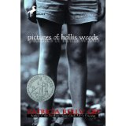
S | 800 | The Great Gilly Hopkins  How can the great Gilly Hopkins be expected to tolerate an ignorant foster mother, a freaky foster brother, or the poetry-loving black man next door? At first Gilly despises them all, but finds herself slowly drawn into their circle of love. | Katherine Patterson | chapter book | 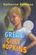
V | 560 | Music of the Dolphins*  A girl raised by dolphins must choose between two worlds in this critically acclaimed novel about what it means to be a human being. | Karen Hesse | chapter book
V | 750 | Esperanza Rising  Esperanza thought she'd always live with her family on their ranch in Mexico — she'd always have fancy dresses, a beautiful home, and servants. But a sudden tragedy forces Esperanza and Mama to flee to California during the Great Depression, and to settle in a camp for Mexican farm workers. Esperanza isn't ready for the hard labor, financial struggles, or lack of acceptance she now faces. When their new life is threatened, Esperanza must find a way to rise above her difficult circumstances — Mama's life, and her own, depend on it. | Pam Munoz Ryan | chapter book | 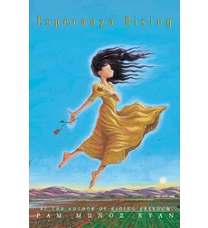
U | 670 | Number the Stars  In 1943, during the German occupation of Denmark, ten-year-old Annemarie learns how to be brave and courageous when she helps shelter her Jewish friend from the Nazis. | Lois Lowry | chapter book

Picture Book Suggestions
GR  LEVEL | LEXILE | TITLE | AUTHOR | BOOK TYPE | PHOTO
V | 590 | Pink and Say  The heart-wrenching true story of Civil War valor in which a 15-year old Yankee soldier, Say, alone and bleeding, is dragged to safety by a fellow Union soldier from the Forty-eighth colored regiment. They are ultimately captured and separated, and Say survived to pass the story down through the author's family. | Patricia Polacco | picture book | 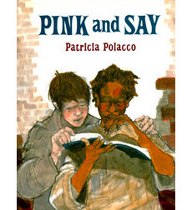
P | 450 | Gleam and Glow  With her noted skill in presenting difficult topics with clarity and sensitivity, Bunting has written an inspiring story based on the true experience of a Bosnian family forced to flee their country during the recent civil war. --Excerpted from the School Library Journal | Eve Bunting | picture book | 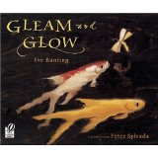
N | 530 | The Giving Tree  A moving parable for readers of all ages that offers an affecting interpretation of the gift of giving and a serene acceptance of another's capacity to love in return. | Shel Silverstein | picture book | 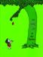
N | AD690 | The Granddaughter Necklace  A mother shares with her daughter stories of the generations of women in their family as each individual has passed along the tales and a glittering necklace to her own daughter. (This book can be used to teach SYMBOLISM.) | Sharon Dennis Wyeth | picture book | 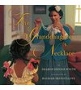
M | AD400 | Wings  “Ikarus Jackson, a new boy on the block, surprises his neighbors one day by flying above the rooftops with his "long, strong, proud wings." People start to whisper, though, and soon those whispers turn to taunts, disdain, and finally even dismissal from school. One quiet girl, someone who knows loneliness herself, doesn't think the winged boy is strange. She runs through the streets, searching the clouds for her exiled schoolmate, only to find a policeman yelling at him to get down from the edge of a building where he perched with the pigeons. . . She musters her strength to tell the laughing onlookers to leave him alone, and she tells her new friend "what someone should have long ago"--that his flying is beautiful.  Christopher Myers, who illustrated the Coretta Scott King Honor Book Black Cat and the Caldecott Honor Book Harlem shines in this simple, lovely tribute to individualism. . .” –Amazon.com Editorial Review | Christopher Myers | picture  book | 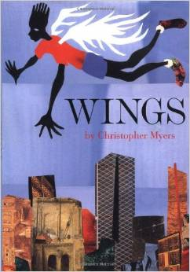
W | AD620 | The Harmonica  When the Nazis invaded Poland, a family is split apart. The parents are sent to one concentration camp, their son to another. Only his father's gift, a harmonica, keeps the boy's hopes alive and, miraculously, ensures his survival. . . A testament to the human spirit and the transcendent power of music. | Tony Johnston | Picture Book | 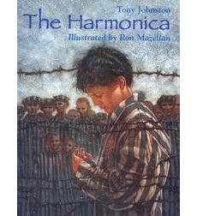
NA | 640 | Faithful Elephants  A zookeeper recounts the story of John, Tonky, and Wanly, three performing elephants at the Ueno Zoo in Tokyo, whose turn it is to die, and of their keepers, who weep and pray that World War II will end so their beloved elephants might be saved. | Yukio Tsuchiya | picture book | 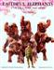
 |  | Selections from Baseball in April & Other Stories  In this collection of short stories, the small events of daily life reveal big themes-love and friendship, youth and growing up, success and failure. Calling on his own experiences of growing up, Gary Soto brings to life the joys and pains of young people everywhere. | Gary Soto | short stories | 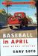

Familiar Mentor Texts from Previous Reading and Writing Units of Study
GR  LEVEL | LEXILE | TITLE | AUTHOR | BOOK TYPE | PHOTO
T | 520 | The Tiger Rising*  After Rob's mother dies, and he and his father move to a new town to get a fresh start, he discovers a caged tiger in the woods. An emotionally rich story about a boy caught in the powerful grip of grief. (Examples of FORESHADOWING are present in this novel.) | Kate DiCamillo | chapter book | 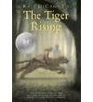
R | 610 | Edward’s Eyes  Edward is one of a large and close family that loves baseball, music, books, and each other, and when he unexpectedly dies and his parents donate his organs, his wonderful eyes go to a perfect recipient. (This book can be used to teach FORESHADOWING.) | Kate DiCamillo | chapter book | 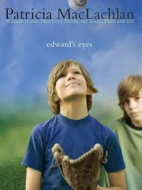
R | 610 | Because of Winn Dixie*  Ten-year-old India Opal Buloni's mother walked out on her seven years ago, and she's been asking about her ever since — so that she won't forget her mom. But when she moves to Florida, and befriends a lively stray dog, the canine helps her meet some unusual characters who teach her about love, life, and forgiveness. (*The dog, Winn Dixie, can be used to teach SYMBOLISM.) | Kate DiCamillo | chapter book | 