Grade 5 Mentor Texts:
Historical Fiction

The following books all fall under the category of historical fiction; stories that could have happened during a particular time period/event in history. It is important to distinguish these books from narrative nonfiction (typically biographies), which might be useful as teaching resources during your Social Studies block. For the purposes of modeling, this text set features books around the topic of the American Revolution, a topic that is in the Grade 5 Social Studies Curriculum.

1) During the Read Aloud, select a new novel to read such as:
- The Fighting Ground, Avi (in collection)
- Attack of the Turtle, Drew Carlson
- Sophia’s War, A Tale of the Revolution, Avi
- Johnny Tremain, Esther Forbes
- My Brother Sam is Dead, James and Christopher Collier (in collection)
- Sarah Bishop, Scott O’Dell
- Betsy Zane, The Rose of Fort Henry, Lynda Durrant

NOTE: Most of these novels are at a slightly higher reading level than what might be expected of most fifth graders for guided or independent reading, and thus makes strong choices for read alouds.

2) Choose a few picture books that could also be interspersed periodically during the Read Aloud time.
- Sleds on Boston Common, Louise Borden
- Daniel Brown at the Battle of Lexington, Ellen Leroe
- The Scarlet Stockings Spy, Trinka Hakes Noble
- Samuel’s Choice, Richard Berleth
- Katie’s Trunk, Ann Turner
- The Ride, The Legend of Betsy Dowdy, Kitty Griffin

Historical Fiction Text Sets - Grade 4

American Revolution
MENTOR TEXTS: Novels

Read Aloud Suggestions
GR  LEVEL | LEXILE | TITLE | AUTHOR | BOOK TYPE | PHOTO

V | 580 | The Fighting Ground  He may be just thirteen, but Jonathan knows he's ready to go to the war against the British. He can handle a gun. He yearns to battle for glory, just like his brother and cousin.  So when Jonathan hears the tavern bell toll, calling men to fight, he runs to join them. He doesn't realize that in just twenty-four hours, his life will be forever altered— by the war, by his fellow soldiers, and by the terrible choices he must make. --Scholastic | Avi  (in collection) | chapter | 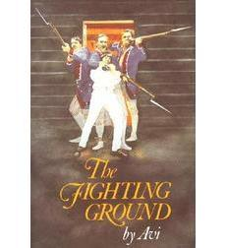
n/a | n/a | Attack of the Turtle  This book is set in 1776 in the midst of the Revolutionary War in the USA. 14-year-old Nathan Wade is a patriot but he's too young to join the fight but when his cousin David arrives with his new invention - a water machine that can explode bombs underwater - Nathan is drawn into the action. David wants to launch his submarine against the British warships in New York harbor. It captures the drama of the first submarine used in naval warfare and the struggles of a teenager overcoming self-doubt. --Scholastic | Drew Carlson | chapter | 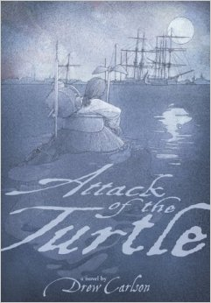
Y | 730 | Sophia’s War: A Tale of the Revolution  In 1776, young Sophia Calderwood witnesses the execution of Nathan Hale in New York City, which is newly occupied by the British army. Sophia is horrified by the event and resolves to do all she can to help the American cause.  Recruited as a spy, she becomes a maid in the home of General Clinton, the supreme commander of the British forces in America. Through her work she becomes aware that someone in the American army might be switching sides, and she uncovers a plot that will grievously damage the Americans if it succeeds. But the identity of the would-be traitor is so shocking that no one believes her, and so Sophia decides to stop the treacherous plot herself, at great personal peril: She’s young, she’s a girl, and she’s running out of time. And if she fails, she’s facing an execution of her own. –Scholastic | Avi | chapter | 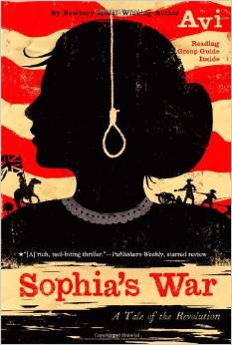
Z | 840 | Johnny Tremain  Because Johnny is proud of the work he does as a silversmith's apprentice, his master warns him that pride goes before a fall. When Johnny violates the law by working on Sabbath Day, his hand is maimed by hot silver and he must find a new profession. His search lands him in the middle of America's fight for freedom. --Scholastic | Esther Forbes | chapter | 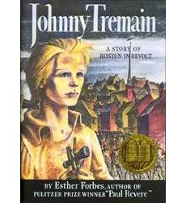
Y | 770 | My Brother Sam is Dead  This young adult novel, which successfully captures the pain of the Revolutionary War, is a fine example of historical fiction. The American Revolution was a war that divided families (English loyalists versus eager Patriots) and one of the families being torn apart is the Meeker family. Young Tim sees his 16-year-old brother join the militia to fight the British, while his father tries to remain loyal to the crown. Their hometown of Redding Ridge, Connecticut is a Tory town, and it is a constant struggle for the family to remain neutral. As the war progresses, Tim has to learn some very hard lessons: Life does not always follow the easiest and happiest course.  Readers will be drawn in by compelling characters, and also by the novel's well-crafted historical backdrop. The Collier brothers have written a story that reaches across historical boundaries, and has become a modern-day classic. --Scholastic | James and Christopher Collier  (in collection) | chapter | 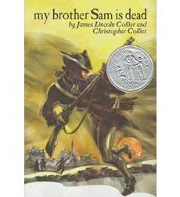
X | 760 | Sarah Bishop  Left alone after the deaths of her father and brother, who take opposite sides in the War of Independence, Sarah Bishop flees from the British who seek to arrest her and struggles to shape a new life for herself in the wilderness. --Scholastic | Scott O’Dell | chapter | 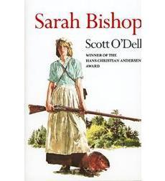
n/a | 750 | Betsy Zane, The Rose of Fort Henry  Thirteen-year-old Betsy Zane is bored with her privileged life in Philadelphia, bored with her great-aunt's stories about the old days, and bored with trying to be a lady. She longs to rejoin her brothers at the family homestead along the Ohio River, where she can finally be free to enjoy the unspoiled countryside that she has missed ever since she was forced to leave it as a child.  When her great-aunt dies, Betsy has the opportunity to return to her frontier home. She frees the house slaves, bundles up the few belongings she can carry, and sets off to find safe passage to the homestead she has dreamed about for so long. At Zane Station she finds much excitement--and some tough choices. Her new life forces her to think more deeply about slavery, loyalty, and family. Betsy begins a romance with a dashing young soldier, and takes part in the greatest adventure of her life, a heroic run for gunpowder--a historical event--that saves Fort Henry in what proved to be the final battle of the Revolutionary War.  Based on the true story of Betsy Zane, this exciting account of a real-life heroine's adventures on the western frontier is rich with vivid and carefully researched historical detail. Author's note, bibliography. --Scholastic | Lynda Durrant | Chapter | 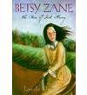

Historical Fiction Text Sets - Grade 5

MENTOR TEXTS: Picture Books

Read Aloud Suggestions
GR  LEVEL | LEXILE | TITLE | AUTHOR | BOOK TYPE | PHOTO

P | 640 | Sleds on Boston Common: A Story from the American Revolution  Nine-year-old Henry Price decides to take his complaint directly to General Gage after British soldiers erect their encampment on Boston Common's best sled run. -Scholastic | Louise Borden | picture | 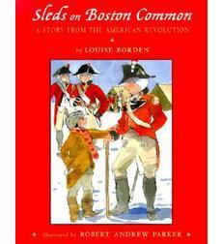
n/a |  | Daniel Brown at the Battle of Lexington  Colonists are preparing for a confrontation with the Redcoats as tension grows in Lexington. Daniel Brown wants to help but he’s too young to train with the militia on Lexington Common. An unexpected turn of events finds Daniel face-to-face with one of the most famous heroes of the American Revolution. Will Daniel prove that even a young boy can help the Patriot cause?  Working closely with members of the Paul Revere House, the Lincoln Minute Men, and the Lexington Minute Men, writer Ellen Leroe has crafted an intriguing story that will draw young readers into the days leading up to the first shot fired on Lexington Common and the beginning of the American Revolution. Illustrator Sally Hinkley has done a superb job of bringing these events to life with more than 15 carefully illustrated pictures depicting the colonists, the battle, and Paul Revere. --Amazon | Ellen Leroe |  | 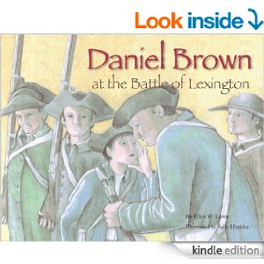
U | 1020 | The Scarlet Stockings Spy  In 1777 Philadelphia during the Revolutionary War, young Maddy Rose helps General Washington's army by spying on the British and using stockings hung on a line to communicate information to her soldier brother. --Scholastic | Trinka Hakes Noble |  | 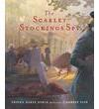
S | 660 | Samuel’s Choice  This story, based on actual incidents and battles in the Revolutionary War, brings readers right into the action — a 14-year-old slave named Samuel faces a difficult choice when only he can help the colonists during the Battle of Long Island, the first battle of the Revolutionary War. Samuel's courage is rewarded with the most precious gift he could receive. --Scholastic | Richard Berleth | picture | 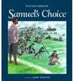
n/a | 660 | Katie’s Trunk  Rebellious colonists have dumped a shipment of tea into Boston Harbor, and all around Katie, men are arming themselves for war. Neighbors don't speak to each other anymore and someone even hissed "Tory!" at Katie because her parents are loyal to England. One unforgettable day, the rebels come. Katie's father tells the family to hide in the woods, but Katie runs back to defend her home. As the rebels rush in to loot the house, Katie hides in her mother's wedding trunk. In a surprise ending, one of the rebels unexpectedly saves her from being discovered, and Katie realizes there may be goodness even in those who seem to be enemies. Ann Turner, acclaimed for her powerful historical picture books, tells the gripping story of one Tory girl's experiences during revolutionary times. --Scholastic | Ann Turner |  | 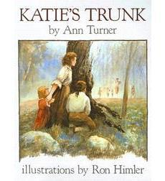
n/a | n/a | The Ride, The Legend of Betsy Dowdy  As the subtitle notes, the story of Betsy Dowdy is a legend. But it’s been told and retold for 200 years, and the derring-do shown by an ordinary North Carolina girl makes for an exciting parable if nothing else. In December of 1775 on a barrier island, 16-year-old Betsy hears the war talk. The Redcoats are on the march to the Great Bridge. Only General Skinner’s militia can stop them, but his camp is 50 dangerous miles away. It’s time for Betsy and her horse Bess to make their move. They swim, they ride through marshland, they’re taken by boat, they ride some more, and finally arrive at Skinner’s camp and ask him to fight the Redcoats. An author’s note describes the victory on the Great Bridge. Most of the text follows the ride and elongates it, probably a bit too much. Still, all the miles and falls and gallops make room for Priceman’s invigorating artwork. Deep night colors, with flashes of orange, swirl with intensity, capturing well the danger, exhaustion, and grit it took to keep going. Perhaps not real, but rousing. --Booklist | Kitty Griffin |  | 